- Copyright for test papers and marking guides remains with West Australian Test Papers.
- The papers may only be reproduced within the purchasing school according to the advertised conditions of sale.
- Test papers must be withdrawn after use and stored securely in the school until Friday 6th December 2013.



YEAR 11 CHEMISTRY
2A/2B
2013

MARKING GUIDE

Section One: Multiple-choice (50 marks)

1 | □ a □ b □ c ■ d |  | 6 | □ a ■ b □ c □ d |  | 11 | ■ a □ b □ c □ d
2 | □ a □ b ■ c □ d |  | 7 | □ a ■ b □ c □ d |  | 12 | □ a □ b ■ c □ d
3 | □ a □ b □ c ■ d |  | 8 | □ a □ b ■ c □ d |  | 13 | □ a ■ b □ c □ d
4 | □ a □ b □ c ■ d |  | 9 | □ a □ b □ c ■ d |  | 14 | □ a □ b □ c ■ d
5 | □ a ■ b □ c □ d |  | 10 | □ a ■ b □ c □ d |  | 15 | □ a □ b ■ c □ d

16 | ■ a □ b □ c □ d |  | 21 | ■ a □ b □ c □ d
17 | □ a ■ b □ c □ d |  | 22 | □ a □ b ■ c □ d
18 | □ a ■ b □ c □ d |  | 23 | ■ a □ b □ c □ d
19 | □ a □ b ■ c □ d |  | 24 | □ a □ b ■ c □ d |  |  | (2 marks per question)
20 | □ a □ b □ c ■ d |  | 25 | □ a □ b □ c ■ d

Section Two: Short answer (80 marks)

Question 26 (5 marks)

Four unlabelled powders were found in a laboratory and analysed to determine the identity of each. The four powders were known to be;

AgNO₃ MgCl₂ Ni(NO₃)₂ BaSO₄

(a) Name the substance you would be able to identify by sight. Explain. (1 mark)

Nickel nitrate - Ni(NO₃)₂ is green

Water was added to the remaining three unidentified solids. Only one did not dissolve.

(b) Name the substance that did not dissolve. (1 mark)

Barium sulfate - BaSO₄

Aqueous sodium carbonate solution was added to the remaining two unidentified solutions. A yellow solid was formed with one and a white solid was formed with the other.

(c) Name the white solid formed. (1 mark)

Magnesium carbonate - MgCO₃

(d) Write the equation for the reaction that took place to produce the yellow precipitate, including in your answer only those species that react. (2 marks)

2 Ag⁺ (aq) + CO₃²⁻ (aq) → Ag₂CO₃ (s)

Question 27 (8 marks)

Oxygen is one of the most abundant substances on Earth, and most elements have the ability to react with it. The table below shows two such oxides.

a) Complete the table below for these species by drawing the structural formula, representing all valence shell electron pairs either as : or – . (2 marks)

 | Carbon dioxide (CO₂) | Sulfur dioxide (SO₂)
Structure  (showing all valence electrons) | 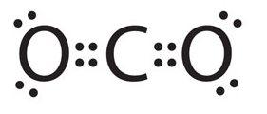or 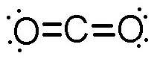 | 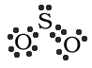 or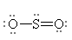
Boiling point  (°C) | - 57 | - 10

b) State one negative environmental impact of each of these gases. (2 marks)

CO₂ | Global warming / enhanced greenhouse effect
SO₂ | Acid rain

Another oxide found on Earth is silicon dioxide, SiO₂, which has a boiling point of 2230 °C.

c) Why is the boiling point of this oxide so much higher than the two oxides shown in the table above? (4 marks)

- SiO₂ is a covalent network substance
- The strong covalent bonds extending throughout the interconnected structure result in a very high boiling point
- CO₂ and SO₂ are both covalent molecular
- So boiling only involves disrupting weak intermolecular forces

Question 28 (7 marks)

The behaviour of two different acids, hydrochloric acid and phosphoric acid, were being compared and some of the results obtained are shown in the table below.

 | 0.5 mol L⁻¹ HCl | 0.5 mol L⁻¹ H₃PO₄
Rate of reaction with zinc metal | fast | slow
Volume of acid required to neutralise 30 mL of 0.5 mol L⁻¹ NaOH | 30 mL | 10 mL

(a) Write the equation and observations for the reaction that would have taken place between the hydrochloric acid and the zinc metal. Include in your answer only those species that react. Describe in full what you would observe, where appropriate including colours, odours, precipitates and gases evolved. (3 marks)

Equation: 2 H⁺ (aq) + Zn (s) → Zn²⁺ (aq) + H₂ (g)

Observations: silver/grey metal dissolves in colourless solution/liquid, colourless
odourless gas produced, test tube feels warm

(b) Explain why the zinc metal reacts more quickly with the hydrochloric acid. (2 marks)

- HCl is a strong acid whereas H₃PO₄ is weak
- Therefore HCl has higher concentration of H⁺ due to complete ionisation

(c) Explain why different volumes of each acid are required to neutralise the same amount of base. (2 marks)

- H₃PO₄ is triprotic where as HCl is monoprotic
- Therefore each mole of H₃PO₄ releases 3 mol H⁺ and requires 3 moles of OH⁻ to neutralise

Question 29 (10 marks)

The periodic table is arranged carefully to display many of the trends present in the 92 naturally occurring elements found on Earth. Answer the following questions referring only to the elements labelled.
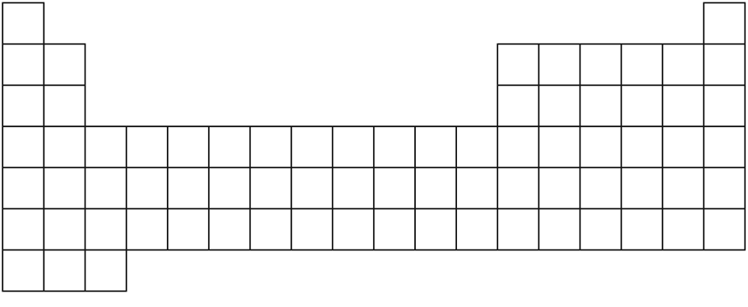
A
B
C
H
D
E
F
G
(a) Which element could have the following subatomic particle arrangement? (1 mark)
protons = 24 neutrons = 31 electrons = 24

F

(b) Which 2 elements would be most similar in their chemical properties? (1 mark)

B and H

(c) Write the electron configuration of element D. (1 mark)

2, 8, 5

(d) Which element is most likely to form an ion with a charge of +2? (1 mark)

C

(e) Which element is diatomic? (1 mark)

E

(f) Which 2 elements would have the same number of valence electrons? (1 mark)

B and H (also A & C)

(g) Write the formula and name of the most likely substance formed when C and E combine. (2 marks)

CE₂ / MgCl₂ – magnesium chloride

(h) Write the formula and name of the most likely substance formed when D and E combine. (2 marks)

DE₃ / PCl₃ – phosphorus chloride

Question 30 (7 marks)

Blake bought a bottle of water to take on the plane with him. He drank it during the flight and put the lid back on. When the plane landed, he noticed that the bottle was a little crumpled and it looked as if the sides of the plastic bottle had been pushed inwards.

(a) Explain, in terms of the kinetic theory, what has caused the bottle to become deformed like this. (3 marks)

- lower air pressure during flight, becomes much greater when on the ground
- the increased pressure at ground level causes increased number of collisions on outside of bottle
- force causes bottle to collapse inwards

Airplanes often fly at an altitude similar to the peaks of very tall mountain ranges. At the top of Mount Everest, water boils at a temperature of 71 °C.

(b) Explain why the boiling point of water is so much lower at this altitude. (2 marks)

- boiling occurs when vp = atm p
- since atm p is lower on Mt Everest vp will equal it sooner and therefore the water boils at a much lower temp

(c) When a liquid is boiling, the temperature of the substance remains constant even though more heat is being added. Explain why this occurs. (2 marks)

- heat is being used to disrupt bonds (increase E_{p}) during a phase changed
- therefore E_{k} & temp remain constant

Question 31 (7 marks)

The reaction between hydrogen peroxide and potassium bromide solution is a redox reaction that produces bromine, which can then be used to disinfect water supplies. The reduction half-equation for this process is shown below.

reduction: H₂O₂ (aq) + 2 H⁺ (aq) + 2 e⁻ → 2 H₂O (l)

(a) Write the oxidation half-equation for the reaction described above. (1 mark)

2 Br ⁻ → Br₂ + 2 e⁻

(b) Write the overall redox equation for this process by combining the oxidation and reduction half-equations. (1 mark)

H₂O₂ + 2 Br ⁻ + 2 H⁺ → 2 H₂O + Br₂

A sample of the bromine generated was added to a solution of sodium iodide.

(c) Write the equation and observations for the reaction that would have taken place. Include in your answer only those species that react. Describe in full what you would observe, where appropriate including colours, odours, precipitates and gases evolved. (3 marks)

Equation: Br₂ (l/aq) + 2 I⁻ (aq) → I₂ (s/aq) + 2 Br – (aq)

Observations: red liquid / orange solution added to colourless solution, brown solution / purple solid forms

Another reaction involving bromine is shown below.

4 Br₂ (aq) + H₂S (g) + 4 H₂O (l) → SO₄²⁻ (aq) + 10 H⁺ (aq) + 8 Br ⁻ (aq)

(d) Which substance is the reductant (reducing agent) in the reaction above? Support your answer with the use of oxidation numbers. (2 marks)

H₂S, O.N. of S changes from -2 to +6

Question 32 (6 marks)

Calcium is the fifth most abundant element by mass in the Earth’s crust. It is essential for all living organisms and is found in the body within bones and teeth. The table below shows some of the properties of pure calcium metal and the related compound calcium chloride.

 | Ca | CaCl₂
Melting point  (°C) | 842 | 772
Conductivity when solid |  | 
Conductivity when molten |  | 
Physical appearance  (colour, lustre, texture etc) | Silver/grey lustrous solid | White crystal

(a) These two substances have similar melting points but quite different physical appearances. Complete the table above by adding a brief description of each substance. (2 marks)

(b) Draw the structural formula of calcium chloride, representing all valence shell electron pairs either as : or – . (1 mark)

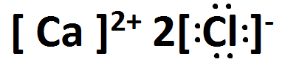

(c) Explain, in terms of structure and bonding, the difference in the ability of the two substances to conduct electricity. (3 marks)

- Ca has metallic bonding with delocalised electrons
- CaCl₂ has ionic bonding consisting of cations and anions
- Ca has mobile charge present in both (s) and (l) states (e⁻ in solid and Ca²⁺ / e⁻ in liquid), while CaCl₂ only has mobile charge (Ca²⁺ / Cl⁻) in (l) state when lattice is molten and ions are dissociated

Question 33 (7 marks)

Ozone (O₃) is an unstable allotrope of oxygen that was discovered in 1839 by Christian Shoenbein. It was named after the Greek word ozein meaning ‘to smell’ due to its sharp odour. When ozone gas reacts with potassium iodide solution and water this produces iodine, oxygen gas and aqueous potassium hydroxide.

(a) Write a balanced full molecular equation for the reaction described above. (2 marks)

O₃ (g) + 2 KI (aq) + H₂O (l) → I₂ (aq/s) + O₂ (g) + 2 KOH (aq)

(b) If litmus indicator was added to the products of this reaction, what colour would you expect to see? (1 mark)

blue

One of the products, aqueous potassium hydroxide, was taken and mixed with some vinegar.

(c) Write the equation for the reaction that took place, including in your answer only those species that react. (1 mark)

CH₃COOH (aq) + OH⁻ (aq) → CH₃COO⁻ (aq) + H₂O (l)
Or
H⁺ + OH⁻ → H₂O

(d) If the potassium hydroxide had instead been mixed with some ammonium nitrate solution, describe in full what you would observe, where appropriate including colours, odours, precipitates and gases evolved. (1 mark)

Pungent (sharp / suffocating) odour / pungent colourless gas produced

(e) State and explain one precaution you should take when handling potassium hydroxide solution. (2 marks)

Wear gloves / safety glasses / avoid skin contact – bases are caustic / corrosive

Question 34 (7 marks)

The three liquids in the table below have vastly different properties and uses.

 | Ethanol (C₂H₅OH) | Pentane (C₅H₁₂) | Water (H₂O)
Vapour pressure  (kPa at 20 °C) | 5.9 | 57.9 | 2.3

(a) Explain, in terms of the kinetic theory, why it would be dangerous to keep a sealed canister of pentane in a non-refrigerated warehouse during summer. (3 marks)

- an increase in temp causes increase in E_{k} and therefore increased vp
- results in increased number of collisions and pressure within container
- container could then explode and pentane is flammable, hence the danger

(b) Which of the three substances in the table would have the highest boiling point? Explain your answer. (2 marks)

- H₂O
- Lowest vp (since boiling is when vp = atm p)

(c) When a little ethanol is mixed with water, it is observed that water no longer freezes at 0 °C. Explain why this is so. (2 marks)

- ethanol disrupts bonding between H₂O molecules / interrupts formation of ordered structure required for solidification
- therefore a lower temp is required before freezing will occur

Question 35 (8 marks)

Consider the diagram below;
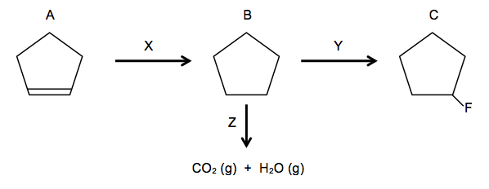
(a) Name compound A. (1 mark)

cyclopentene

(b) Name the reagent that has been added to allow reaction X to take place. (1 mark)

Hydrogen – H₂

(c) Name the type of reaction occurring at X. (1 mark)

Addition / hydrogenation

(d) Name the reagent that has been added to allow reaction Y to take place. (1 mark)

Fluorine – F₂

(e) Name the type of reaction occurring at Y. (1 mark)

Substitution

(f) Name compound C. (1 mark)

fluorocyclopentane

(g) Write a balanced full molecular equation representing reaction Z. (1 mark)

2 C₅H₁₀ + 15 O₂ → 10 CO₂ + 10 H₂O

(h) Under what conditions would carbon monoxide have been produced instead of carbon dioxide in reaction Z? (1 mark)

Limited O₂

Question 36 (8 marks)

An electrolytic cell was set up as shown in the diagram below, using aqueous sodium chloride as the electrolyte. The reactions occurring at each electrode are also indicated in the diagram.
power
pack
NaCl (aq)
graphite electrode
graphite electrode
H₂O(l) + 2e⁻ → H₂(g) + 2OH⁻(aq)
2H₂O(l) → O₂(g) + 4H⁺(aq) +4e⁻
cathode
anode
←anions←
→electrons(

(a) On the diagram above label the cathode and anode, and label and show the direction of electron flow and the direction of anion flow. (3 marks)

(b) What is the function of the graphite electrodes? (1 mark)

Provide inert conductive surface for electron transfer

If molten sodium chloride, NaCl (l), had been used as the electrolyte instead of aqueous sodium chloride, NaCl (aq), very different reactions would have occurred at the cathode and anode.

(c) Write the cathode and anode half equations for the molten NaCl cell. (2 marks)

cathode: Na⁺ + e⁻ → Na

anode: 2 Cl⁻ → Cl₂ + 2e⁻

(d) Why are such different products formed in this case? (1 mark)

No water present that can be preferentially oxidised or reduced

(e) What is the name of the industrial process where molten NaCl is electrolysed? (1 mark)

Electrowinning (Down’s process / cell)

End of Section Two

Section Three: Extended answer (70 marks)

Question 37 (13 marks)

An experiment was designed in order to determine the rate of reaction between marble chips (mostly composed of calcium carbonate, CaCO₃) and hydrochloric acid. The equipment was set up as shown in the diagram below. 5.00 g of marble chips were placed into a conical flask containing excess hydrochloric acid and the mass of the flask was weighed at intervals until the reaction had completely stopped. The equation for the reaction that took place in the flask is also shown below. The results were recorded in the table.
Time (s)Mass (g)01852184.25183.610183.415183.320183.230183.2
185.0 g
hydrochloric acid
marble chips
balance

CaCO₃ (s) + 2 HCl (aq) → CaCl₂ (aq) + CO₂ (g) + H₂O (l)

(a) Sketch a graph that illustrates the results of this experiment. (4 marks)

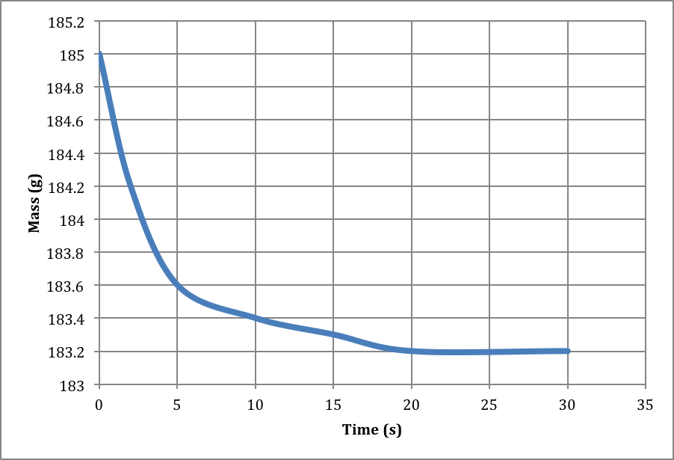

(b) Explain, in terms of the collision theory, why the reaction rate changes. How is this change in reaction rate related to the shape of the graph? (3 marks)

- at start many reactant particles are present, frequent collisions
- products being made quickly therefore slope of graph is steep
- as time progresses, less collisions of reactant particles, slope of graph decreases to horizontal (as one or both of the reactants have been entirely used up)

(c) What test could you perform to confirm that the gas produced was carbon dioxide? (1 mark)
limewater test

(d) Calculate the mass of carbon dioxide produced from the marble chips. (1 mark)

185 – 183.2 = 1.8 g

(e) Calculate the percent by mass of calcium carbonate in the marble chips. (4 marks)

n(CO₂) = m/M
= 1.8 / 44.01
= 0.0408998

n(CaCO₃) = n(CO₂)

m(CaCO₃) = nM
= 0.0408998 x 100.09
= 4.09366 g

% purity = 4.09366 / 5.00 x 100
= 81.8732
= 81.9 % CaCO₃ in the marble chips

Question 38 (15 marks)

Diborane, B₂H₆, can be used as a rocket fuel due to the fact that it ignites easily with air. It is a colourless gas with a sickly sweet odour and can cause skin and eye irritation and shortness of breath if inhaled. There are many methods that can be used to prepare diborane and one of the most common is shown below. This reaction has a yield of about 30%.

__4__ BF₃ (g) + __3__ NaBH₄ (s) → __2__ B₂H₆ (g) + __3__ NaBF₄ (s)

(a) Balance the chemical equation above. (1 mark)

The combustion equation for diborane, as would occur in the fuel tank of a rocket, is shown below. The activation energy for this reaction is 346 kJ.

B₂H₆ (g) + 3 O₂ (g) → B₂O₃ (s) + 3 H₂O (l) + 2168 kJ

(b) Sketch a labelled potential energy diagram for the combustion of diborane. Label the activation energy, enthalpy change and transition state. (5 marks)

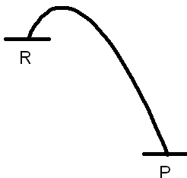
transition state
ΔH = -2168 kJ
E_{a} = 346 kJ
Progress of reaction
Potential energy (kJ)

(c) State the value of the following; (2 marks)

Activation energy (E_{a}) of the reverse reaction 2514 kJ

Heat of reaction (ΔH) of the reverse reaction +2168 kJ

(d) Explain what information the heat of reaction (ΔH) for the combustion of diborane provides in terms of the bond-breaking and bond-making processes that occur. (3 marks)

- exothermic reaction
- therefore energy put in to break the bonds is less than
- energy released when new bonds form

Diborane is also soluble in water and reacts to form boric acid and hydrogen gas according to the equation below.

B₂H₆ (g) + 6 H₂O (l) → 2 H₃BO₃ (aq) + 6 H₂ (g)

(e) If 9.27 L of diborane, stored at STP, was dissolved into 1.15 L of water, what concentration of boric acid would be produced? (Assume all the gas dissolves). (3 marks)

n(B₂H₆) = v/22.71
= 9.27 / 22.71
= 0.40819

n(H₃BO₃) = 2 x n(B₂H₆)
= 0.8163804

C(H₃BO₃) = n/V
= 0.8163804 / 1.15
= 0.709896 mol L⁻¹
= 0.710 mol L⁻¹

(f) What test could you perform to confirm that hydrogen gas was being produced? (1 mark)

pop test

Question 39 (13 marks)

A hydrocarbon was sent for analysis to determine whether it was an alkane or alkene. The hydrocarbon sample was burnt in a stream of pure oxygen and this produced 0.321 g of carbon dioxide and 0.131 g of water vapour.

(a) Calculate the empirical formula of the compound. (5 marks)

 | C | H
m | 0.0875985 | 0.014658969
n | 0.0072937968 | 0.014542628
ratio | 1 | 2

Therefore EF is CH₂

(b) If the molecular weight of the compound was known to be 42.1 g mol⁻¹, calculate the molecular formula of the compound. (2 marks)

M(EF) = 14.016

M / M(EF) = 42.1 / 14.016
= 3

Therefore MF is C₃H₆

(c) Draw and name the two possible isomers of the compound. (4 marks)

Structure:  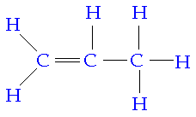  IUPAC name: propene | Structure:  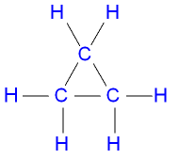  IUPAC name: cyclopropane

(d) When the compound was mixed with bromine water, Br₂(aq), no reaction was observed. Which of your 2 isomers must be the correct structure? Explain your answer. (2 marks)

- cyclopropane
- no double bond so cannot undergo addition (would not react or would only react extremely slowly with Br₂ in the presence of UV light)

Question 40 (14 marks)

Calcium hypochlorite, Ca(OCl)₂, is a grey-white solid that can be used as a bleaching agent. It is often used to chlorinate pool water as it effectively kills bacteria and algae.

Raymond was trying to get his pool ready for summer, so he measured out 300 g of solid ‘pool shock’ and tipped it into his pool which had a capacity of 25 000 L. If the ‘pool shock’ was 65.0% calcium hypochlorite;

(a) Calculate the final concentration of Ca(OCl)₂, in mol L⁻¹, in Raymond’s pool once all the ‘pool shock’ had dissolved. (3 marks)

m(Ca(OCl)₂) = 65/100 x 300
= 195 g

n(Ca(OCl)₂) = m/M
= 195 / 142.98
= 1.363827

C(Ca(OCl)₂) = n/V
= 1.363827 / 25000
= 5.455308 x 10⁻⁵ mol L⁻¹
= 5.46 x 10⁻⁵ mol L⁻¹

Once calcium hypochlorite is added to water it forms hypochlorous acid and calcium hydroxide as shown in the equation below.

Ca(OCl)₂ (s) + 2 H₂O (l) → 2 HClO (aq) + Ca(OH)₂ (s)

(b) Hypochlorous acid is a monoprotic acid. Explain what this means, using an equation to support your answer. (2 marks)

- contains one acidic / ionisable hydrogen per molecule
- HClO D H⁺ + ClO⁻ OR
HClO + H₂O D H₃O⁺ + ClO⁻

The calcium hydroxide formed is only slightly soluble in water and can clog up the pool filter, requiring the use of an anti-scaling agent to remove the solid.

(c) Is calcium hydroxide a strong, weak or non-electrolyte? Explain your answer. (2 marks)

- strong
- all ionic substances are strong electrolytes (to the extent that it does dissolve, it exists completely as ions)

Calcium hypochlorite can also be used to manufacture chlorine gas by heating with dilute hydrochloric acid, as shown in the equation below.

Ca(OCl)₂ (s) + 2 HCl (aq) → Ca(OH)₂ (aq) + 2 Cl₂ (g)

If 15.6 kg of calcium hypochlorite was heated with 98.0 L of 2.17 mol L⁻¹ hydrochloric acid;

(d) Calculate the limiting reagent. (4 marks)

 | Ca(OCl)₂ | HCl
n(present) | n = m/M  = (15.6 x 1000) / 142.98  = 109.1061687 | n = cV  = 2.17 x 98  = 212.66
n(required) | n = 212.66 / 2  = 106.33 | n = 109.1061687 x 2  = 218.2123374

Therefore HCl is LR

OR

Stoichiometric ratio HCl / Ca(OCl)₂ = 2 / 1 = 2
Actual ratio HCl / Ca(OCl)₂ = 212.66 / 109.1061687 = 1.95

Therefore HCl is LR

(e) Calculate the mass of excess reagent. (3 marks)

n(xs Ca(OCl)₂) = 109.1061687 – 106.33
= 2.7761687

m(xs Ca(OCl)₂) = nM
= 2.7761687 x 142.98
= 396.9366 g
= 397 g

Question 41 (15 marks)

Ammonium nitrate is manufactured in large quantities and has many different uses. It is the main ingredient in instant cold packs, it is commonly used in explosives as an oxidising agent, and due to the high nitrogen content it is also widely used in agriculture as a fertiliser.

Ammonium nitrate must be stored and transported carefully or it may decompose according to the reaction below. This process is very exothermic and can cause an explosion.

2 NH₄NO₃ (s) → 2 N₂ (g) + O₂ (g) + 4 H₂O (l)

(a) Why might the decomposition of ammonium nitrate cause an explosion (other than because it is an exothermic process)? (1 mark)

O₂ produced allows other substances to burn at a much higher rate
(by acting as an oxidising agent)

(b) If 825 g of ammonium nitrate was to completely decompose, calculate the total volume of gas that would be produced at STP. (3 marks)

n(NH₄NO₃) = m/M
= 825 / 80.052
= 10.305801

n(gas) = 10.305801 / 2 x 3
= 15.45870

V(gas) = 22.71n
= 22.71 x 15.45870
= 351.06712 L
= 351 L

As stated above, ammonium nitrate can be used as a fertiliser as it is water-soluble and contains a high level of nitrogen, which is essential for plant growth.

(c) Write an equation showing ammonium nitrate dissolving in water. (1 mark)

NH₄NO₃ (s) → NH₄⁺ (aq) + NO₃⁻ (aq)

(d) Explain why a solution of ammonium nitrate is a good conductor of electricity whilst a solution of ammonia is not. (4 marks)

- NH₄NO₃ is ionic substance and therefore strong electrolyte
- Lattice will dissociate and mobile ions can carry current
- NH₃ is a weak electrolyte
- Only undergoes partial ionisation therefore much less ions present to carry a current

A sample of ammonium nitrate solution is being diluted and prepared for use as a spray-on fertiliser in a vegetable garden.

(e) What volume of 2.70 mol L⁻¹ ammonium nitrate stock solution should be used to produce 9.00 L of a 0.155 mol L⁻¹ working solution? (2 marks)

V₁ = c₂V₂ / c₁
= (0.155 x 9) / 2.70
= 0.51667 L
= 0.517 L or 517 mL

(f) If 5.00 L of the dilute 0.155 mol L⁻¹ solution was sprayed evenly over a 2 m² vegetable garden, calculate the mass of nitrogen that could potentially be absorbed per cm² of soil.
(Note: 1 m² = 10 000 cm²) (4 marks)

n(NH₄NO₃) = cV
= 0.155 x 5
= 0.775

n(N) = 2 x n(NH₄NO₃)
= 1.55

m(N) = nM
= 1.55 x 14.01
= 21.7155 g

m(N per cm²) = 21.7155 / 20 000
= 0.001085775 g

1.09 x 10⁻³ g per cm²

End of questions

